Catch, Bycatch and Landings of Blue Shark in the Canadian Atlantic

Background

The blue shark (Prionace glauca) is a large temperate and tropical pelagic shark species of the family Carcharhinidae that occurs in the Atlantic, Pacific and Indian oceans. In Canadian waters the blue shark has been recorded off southeastern Newfoundland, the Grand Banks, the Gulf of St. Lawrence, the Scotian Shelf and in the Bay of Fundy.
At certain times of the year, it is probably the most abundant large shark species in eastern Canadian waters.

The blue shark is a highly migratory viviparous species, with tagging results suggesting that there is a single well-mixed population in the North Atlantic. Females reach sexual maturity at a length of 2.2 to 3.2 m, while for males it is achieved at lengths of 1.8 to 2.8 m. After copulation, the females may retain and nourish the spermatozoa in the oviducal gland for months or years while awaiting ovulation. Once the eggs have been fertilized there is a gestation period of between 9 and 12 months. The new-born pups measure 40 to 51 cm in length and litters usually consist of between 25 to 50 individuals.

The diet of the blue shark includes both pelagic fishes and groundfish,, as well as marine mammals in larger sharks. The only likely natural predators are other large sharks. Further information on blue shark biology is available at the web site for the Shark Research Laboratory (www.mar.dfo-mpo.gc.ca/science/shark).

Summary

- International efforts are now underway to prepare a first stock assessment for North Atlantic blue sharks.
- Canadian landings since 1990 have averaged 52t.
- Observer data indicate that virtually no blue shark are retained.
- Blue shark bycatch accounted for 26-40% of the total large pelagic catch in the Japanese large pelagic fishery.
- Blue shark bycatch accounts for 47-152% of the Canadian tuna and swordfishery, and 7% of the porbeagle fishery.
- Total catch in the Japanese fishery averaged 161t annually between 1986-1999.
- Total estimated Canadian catch ranged between 156-3878 mt since 1986, with an overall mean catch of 1175mt.
- The bycatch rate could be twice as high as was reported, although survival of released sharks would reduce bycatch mortality.

The Issue

The sustainable catch level for blue sharks is unknown, both in Canadian waters and in the North Atlantic. FAO’s recently released International Plan of Action for the Conservation and Management of Sharks concluded that many of the world’s shark species are severely depleted (FAO 1998). The inherent vulnerability of sharks and other elasmobranchs to overfishing and stock collapse was also highlighted in an American Fisheries Society policy statement, which noted that most elasmobranch populations decline more rapidly and recover less quickly than do other fish populations (Musick et al. 2000). Indeed, numerous authors have noted the low productivity of elasmobranchs compared with teleosts, which is largely a result of their low fecundity and late age at sexual maturation. Although the blue shark is among the more productive of pelagic shark species, the sustainability of recent bycatches is unknown. International efforts are now underway to prepare a first assessment of stock status for North Atlantic blue sharks, and Canada is participating in this process.

The Fishery
Year | 1994 | 1995 | 1996 | 1997 | 1998 | 1999 | 2000 | 2001 | 2002
TAC¹ | - | 250 | 250 | 250 | 250 | 250 | 250 | 250 | 250
Landings (t) | 138 | 152 | 24 | 20 | 15 | 67 | 35 | 8
Canadian catch² | 503 | 3878 | 228 | 355 | 2252 | 740 | 1102 | -
Foreign catch² | 299 | 170 | 224 | 26 | 33 | 292 | 3 | 0
TOTAL | 802 | 4048 | 452 | 381 | 2285 | 1032 | 1105 | -
¹ for directed fishery only
² minimum estimate of landings and discards

There is virtually no directed fishery for blue sharks in the Canadian Atlantic (NAFO subareas 2 - 5). Only Canadian, Japanese and Faroese vessels are known to have caught significant quantities of blue shark in Canadian waters. Reported landings peaked at around 250t in 1994, declining thereafter to only 8t in 2001. In the northwest Atlantic as a whole, mean reported catches are somewhat larger, averaging 200-500t in the 1990s. North Atlantic nominal catches are substantially larger, reaching 25,000t in 1998. However, much of this catch is believed to have been caught in the northeast Atlantic.

Blue shark landings by Canadian vessels are very small, averaging 52t per year since 1990. Most of the landings are from longlines, although recreational shark fishing derbies averaging 10t annually have accounted for a growing proportion of the landings in recent years. Most of the catch is restricted to the Scotian Shelf in the first half of the year, extending northwards into the Gulf of St. Lawrence and the Newfoundland shelf between July and December.

Canada introduced a shark management plan in 1995 which defined a non-restrictive catch guideline of 250t for the directed shark fishery, restricted the recreational fishery to hook and release only, and specified scientific data requirements. The non-restrictive catch guidelines approximated the reported landings of the species in Atlantic Canada in 1992 and was not based upon estimates of stock abundance. Fishing gears to be used in the directed fishery were limited to longline, handline or rod and reel gear for commercial licenses and to rod and reel only for recreational licenses. No catch restrictions were put on shark caught as bycatch in large pelagic fisheries. In subsequent management plans, the precautionary TAC of 250t for mako and blue shark remained unchanged.

Observed Bycatch

The International Observer Program (IOP) has maintained 100% coverage of foreign fisheries in the Canadian zone since 1987, and about 5% coverage of domestic longline vessels. Observed catches by Canadian, Japanese and (in earlier years) Faroese longliners since 1990 have averaged about 250t annually. Blue shark bycatch in fisheries other than that for large pelagics was much smaller, although the 1-2t observed on 4X groundfish longlines could add up to 20-60t annually when pro-rated across non-observed trips. In most years, virtually all of the blue shark catch was discarded. Most of the Canadian bycatch occurred in deep waters off the continental shelves of Nova Scotia and Newfoundland, increasing in quantity through the year. Significant catches have also been observed in the deep basins of the Scotian Shelf. Catch locations of Japanese longliners occurred almost exclusively off the continental shelf, and were mainly restricted to the first and last quarters of the year. The location of blue shark bycatch in the Canadian and Faroese porbeagle fishery was somewhat different, being more localized on the Scotian and Newfoundland shelves, as well as in the Gulf of St. Lawrence.

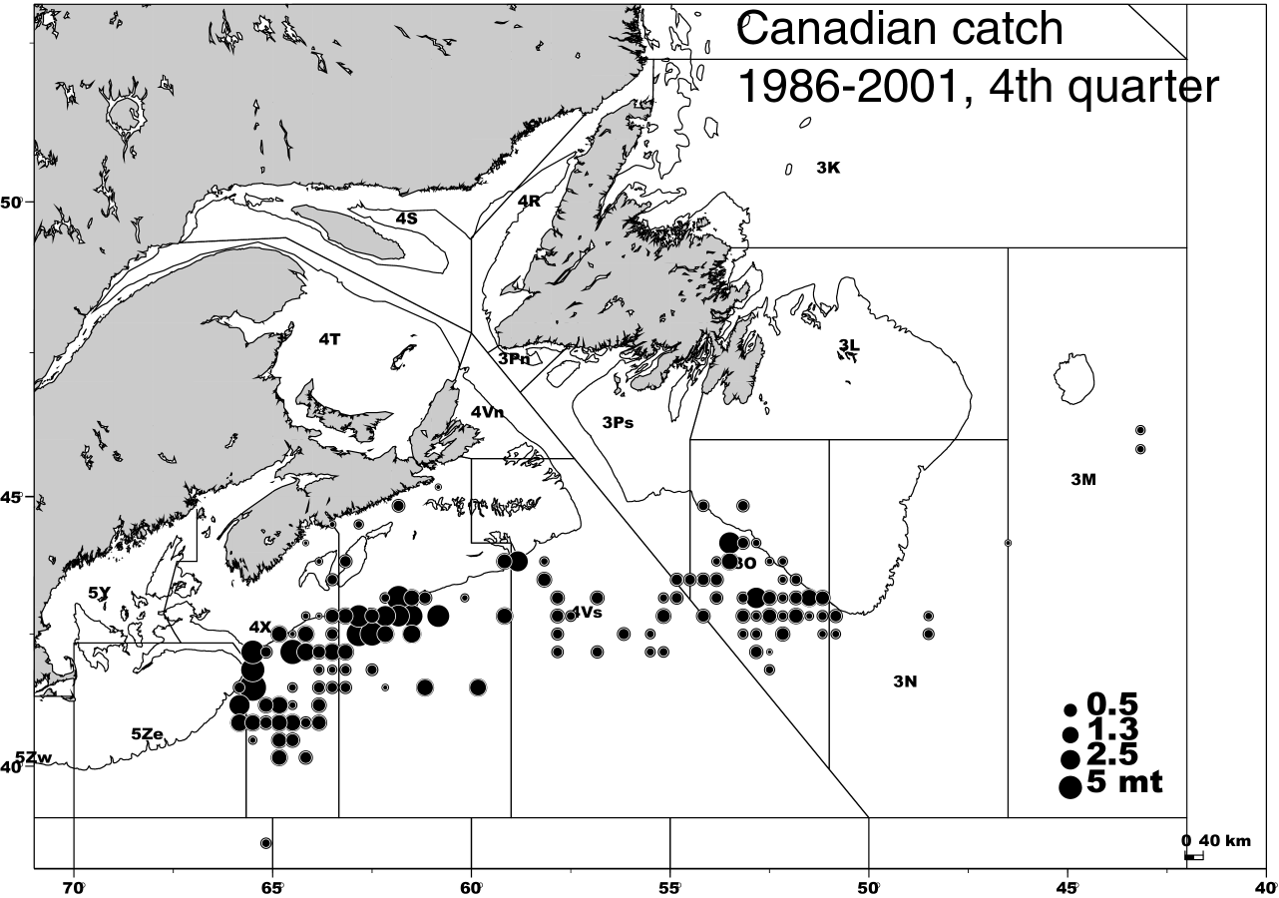

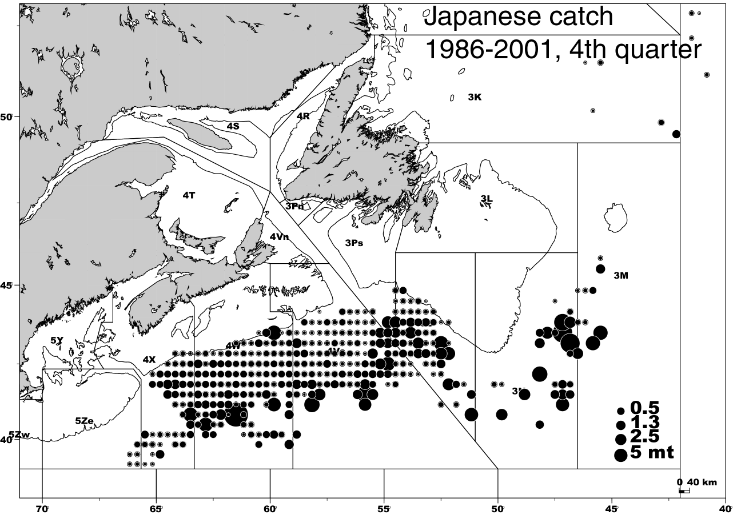

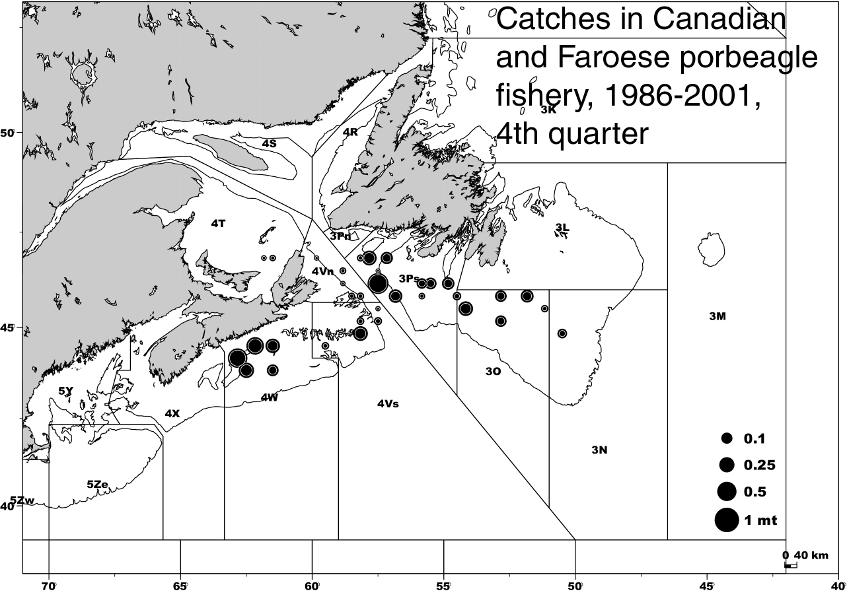

Estimation of Annual Bycatch

To determine the magnitude of the blue shark bycatch in the various large pelagic fisheries, bycatch was estimated by country, fishery, quarter and year from Maritimes IOP observations made between 1986-2000, with bycatch defined as the summed weight of the kept and discarded blue sharks relative to the summed large pelagic catch (tuna, swordfish and porbeagle). The analysis was restricted to Canadian, Japanese and Faroese vessels, since they accounted for more than 99% of the blue shark catch. Bycatch in the foreign fisheries was fully observed, so estimation was not necessary. Total pelagic catch for each cell was determined from ZIF for Canadian vessels, and from IOP for foreign vessels.

For the 6 large pelagic fisheries other than porbeagle, mean blue shark bycatch accounted for 26-152% of the total large pelagic catch. Blue shark bycatch in the porbeagle fishery was substantially less, averaging 7%. The bycatch rate is slightly higher in the Canadian fishery (47-152%) than in its Japanese counterpart (26-40%).

Blue shark bycatch proportions for each year and quarter in the Canadian bluefin tuna, swordfish, albacore, yellowfin, and bigeye tuna fisheries often exceeded 50%. Annual bycatch estimates for these fisheries averaged about 100mt in each fishery except swordfish. Swordfish bycatches averaged about 1100mt per year, reaching 3500mt in some years, although substantial year to year variations were evident.

Blue shark bycatch proportions in the porbeagle fishery tended to be small in both the Canadian and Faroese longline fisheries, averaging 7%. Annual estimates averaged about 50t.

Blue shark bycatch proportions in the Japanese tuna and swordfish fisheries averaged about 35%. Total bycatch in the Japanese fishery averaged 161t annually between 1986-1999.

For both the domestic and foreign fisheries, most of the blue shark bycatch was caught in the 3rd or 4th quarters; very little was taken in the first quarter.

Anecdotal reports suggest that some observers recorded blue sharks in the catch only if they were brought onto deck before discarding. Since some Canadian vessels routinely cut off the leader of blue sharks before reaching deck, it is likely that the estimated bycatch proportions represent a minimum estimate, which underestimates actual Canadian bycatch. In order to estimate the extent of any such underreporting, we prepared a second set of analyses which assumed that blue sharks were caught in all sets, but reported only in some; thus it sets an upper limit to the bycatch estimate. These maximum estimates were used to provide context for the interpretation of the bycatch in some fisheries.

It appears that blue shark bycatch on Canadian vessels fishing swordfish, other tunas, and possibly bluefin tuna was underreported by some observers, and that actual bycatch lies somewhere in the range defined by the minimum and maximum bycatch estimates. Minimum bycatch estimates appear to be valid for the Japanese and porbeagle fisheries, since most sharks were brought on deck in Japanese fisheries. However, minimum and maximum estimates differ by a factor of two for some years in the Canadian swordfish and tuna fisheries.

A confounding issue in the interpretation of blue shark bycatch concerns the subsequent survival or mortality of the discarded sharks. Virtually all blue shark are discarded after capture. Between 1986 and 1994, a large proportion of shark bycatch was killed by finning. In principle, sharks discarded alive and in good health after 1994 should not be included in any calculations of fishing mortality or nominal catch. Many shark species suffer a high hooking mortality because of their requirement for continued swimming to move water over their gills to breathe. However, observer observations from the 2000 and 2001 Canadian pelagic longline fishery noted that 88-93% of the blue sharks captured were released alive. Of those, an additional 3-17% were noted as being injured at the time of release. It is not possible to determine what proportion of the released sharks actually survived the capture event. Assuming some additional mortality of released sharks, our estimates of recent bycatch would be somewhat higher than the bycatch that was actually killed.

Canadian large pelagic fisheries caught more than 80% of the total estimated annual blue shark catch in most years. Total minimum estimated Canadian catch ranged between 156-3878t since 1986, with an overall mean catch of 1175t. The percentage increased to 100% in 2000-2002 when the Japanese fishery in Canadian waters was closed. Total minimum annual catches have ranged between 243-4048t since 1986, with an overall mean catch of 1346t. Maximum annual catches have averaged 2315t.

For More Information

Contact:

Steven Campana
Marine Fish Division
Bedford Institute of Oceanography
P.O. Box 1006, Dartmouth
Nova Scotia B2Y 4A2

TEL: (902) 426-3233
FAX: (902) 426-9710
E-Mail: campanas@mar.dfo-mpo.gc.ca
Shark Web site:
www.mar.dfo-mpo.gc.ca/science/shark

References

Campana, S., P. Gonzalez, W. Joyce and L. Marks. 2002. Catch, Bycatch and Landings of Blue Shark in the Canadian Atlantic. DFO Can. Sci. Adv. Sec. Res. Doc. 2002/101.

FAO (Food and Agriculture Organization of the United Nations). 1998. International Plan of Action for the Conservation and Management of Sharks. Document FI:CSS/98/3, Rome.

Musick, J.A., G. Burgess, G. Cailliet, M. Camhi, and S. Fordham. 2000. Management of Sharks and their Relatives (Elasmobranchii). Fisheries 25(3):9-13.

This report is available from the:

Maritime Provinces
Regional Advisory Process
Department of Fisheries and Oceans
P.O. Box 1006, Stn. B203
Dartmouth, Nova Scotia
Canada B2Y 4A2
Phone number: 902-426-7070
e-mail address: myrav@mar.dfo-mpo.gc.ca

Internet address:
http://www.mar.dfo-mpo.gc.ca/science/rap/ internet/index.htm

La version française est disponible à l’adresse ci-dessus.

Correct citation for this publication:

DFO, 2002. Catch, Bycatch and Landings of Blue Shark in the Canadian Atlantic. DFO Science Fisheries Status Report 2002/02E.

