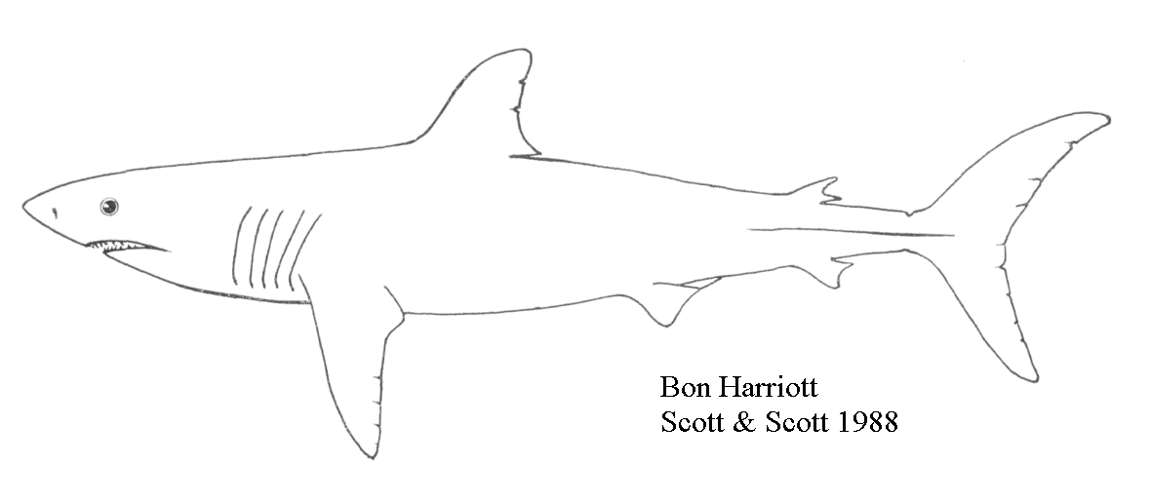
Porbeagle Shark in NAFO
Subareas 3 - 6

Background

The porbeagle shark (Lamna nasus) is a cold-temperate species that occurs in the north Atlantic, south Atlantic and south Pacific oceans. The species range extends from Newfoundland to New Jersey and possibly to South Carolina in the west Atlantic and from Iceland and the western Barents Sea to Morocco and the Mediterranean in the east Atlantic. In the northwest Atlantic, this pelagic shark inhabits inshore and offshore waters colder than 14°C, and is commonly seen in the 5 - 10°C range. Porbeagle sharks move onto the Scotian Shelf in early spring and into the Gulf of St. Lawrence and onto the Grand Banks during the summer and early fall. Segregation occurs by sex and size. Mating occurs in the early fall off southern Newfoundland. Porbeagle move south and possibly into deeper water in late fall, but their winter distribution is unknown.

Independent tagging studies all indicate that there is little or no exchange between porbeagle of the east and west Atlantic. The same studies suggest that only one stock resides in the northwest Atlantic, migrating between the Gulf of Maine and southern Newfoundland on an annual basis. Therefore, the stock is defined by NAFO SA 3 - 6.

Unlike most of the teleosts (bony fishes), the fertilization of eggs occurs internally in elasmobranchs (sharks, skates and rays). In porbeagle sharks, fertilized eggs continue to develop in the uterus of the female and young are born as fully formed juveniles or "pups" after a gestation period of 8-9 months. The young are born at a relatively large size of 65-70 cm, thus reducing the number of potential predators. Pregnant females continue to release eggs and the embryos obtain nourishment by consuming unfertilized eggs in the uterus. The number of young produced annually averages 4 pups per litter. Males mature at about 174 cm fork length while females mature at about 217 cm fork length. The age of first maturity in males occurs at age 8, but is closer to age 13 in females. Porbeagle sharks live to an age of more than 30 years. Natural mortality is about 0.1 in immature sharks, increasing to 0.2 in mature females. Maximum reported size is 320cm fork length and 250kg; however specimens over 250cm are rare.

The diet of the porbeagle shark consists primarily of midwater and pelagic fishes, but includes squid and groundfish whenever they are available. The only likely natural predators are other large sharks.

Summary

- An intensive research program on porbeagle was carried out between 1998-2001 with the support and funding of the shark fishing industry, and in collaboration with the Apex Predator Program of the National Marine Fisheries Service.
- 1998-2000 landings have been 900-1050t.
- The size composition of the 1999 and 2000 catches was relatively similar between the inshore and offshore fleets, and was dominated by sharks <175cm.
- The porbeagle population is relatively unproductive due to the delayed age at sexual maturation (approx. age 13 in females) and low pup production rate (<4 pups per year).
- Catch rates of immature porbeagle in 2000 were about 30% of the 1991 level. Catch rates of mature porbeagle have declined to 10% of the 1992 level.
- Independent measures of recent fishing mortality based on catch at age, tag recaptures and a population model all indicate that fishing mortality during 1998 – 2000 was around 0.20.
- Biological reference points calculated from a life table analysis and population model indicate that fishing at F_{0.1}=0.18 is unsustainable, and will result in stock collapse. Fishing at F=0.08 results in zero population growth, while F=0.04 to 0.06 approximately corresponds to a maximum sustainable yield (MSY) of about 1000t.
- The current population is seriously depleted and a greatly reduced fishing mortality is required if the population is to recover. An annual catch of 200-250t would correspond to fishing at about MSY and would allow population growth. Annual catches of about 400t would not allow any population growth, nor room for error in the estimates. Current population size appears to be 10-20% of virgin levels.

The Fishery

Landings (t)¹
Year | 1993 | 1994 | 1995 | 1996 | 1997 | 1998 | 1999 | 2000
TAC | - | - | - | - | 1000 | 1000 | 1000 | 850
Foreign | 512 | 5 | 9 | 56 | 4 | 12 | 6 | 0
Canada | 920 | 1573 | 1348 | 1043 | 1317 | 1054 | 955 | 899
TOTAL | 1432 | 1578 | 1357 | 1099 | 1321 | 1066 | 961 | 899

Porbeagle landings (t) by country

The fishery for porbeagle sharks in the Northwest Atlantic (NAFO subareas 3 - 6) started in 1961 when Norwegian vessels began exploratory fishing on a virgin population. These vessels had previously fished for porbeagle in the Northeast Atlantic. They were joined by vessels from the Faroe Islands during the next few years. Reported landings in the Northwest Atlantic rose from about 1,900t in 1961 to more than 9,000t in 1964 and then fell to less than 1,000t in 1970 as a result of a collapse of the fishery. Although the fishery was unrestricted, reported landings were less than 500t until 1989. Reported landings rose to almost 2,000t in 1992, due to increased effort by Faroese vessels and also due to the entry of Canadian interests into this fishery. Faroese participation was phased out of the directed fishery by 1994, at which time total landings by three Canadian offshore pelagic longline vessels and a number of inshore vessels was about 1600t. Since that time, the fishery has been almost exclusively Canadian, with landings declining gradually to 1066t in 1998 in response to quota control. Catches by foreign vessels fishing outside of Canadian waters are unknown, but are believed to be small. Landings in the first half of 1999 and 2000 exceeded 700t each year, and the industry voluntarily restricted fishing over the summer to reserve quota for the fall. Since 1996, approximately two thirds of the directed catch has been made by the two remaining offshore vessels, although the proportion taken by the inshore vessels increased to above 40% in 1999 and 2000.

Canada introduced a shark management plan in 1995 which defined a non-restrictive catch guideline of 1,500t. In 1997, a TAC of 1000t was imposed under the 1997-99 Shark Management Plan. The 2000-2001 Shark Management Plan restricted catches to a total of 1700t over a 2 year period while additional scientific information was collected.

Porbeagle sharks are taken almost exclusively by a Canadian directed longline fishery. By-catch in the Canadian swordfish longline fishery, the Japanese tuna longline fishery, and various inshore fisheries is minimal, seldom exceeding 40t in recent years. Bycatch of other species while directing for porbeagle is also minimal (8%), most of which is blue shark. There is almost no recreational fishery for porbeagle sharks.

The geographic location and timing of the fishery is different for the inshore and offshore fleets. Both fleets fish the Scotian Shelf in the spring, but the offshore fleet concentrates on the Shelf edge while the inshore fishery extends well onto the Shelf. There is little directed effort for porbeagle by the inshore fleet in the fall; most of the fall catch is made by the offshore fleet fishing off southern Newfoundland and in the Gulf of St. Lawrence. There was no directed fishery during the summers of 1999 and 2000 when the industry voluntarily agreed to reserve quota for the fall. Fall catches were voluntarily restricted to 100t in Subarea 3.

Location and size composition of catch

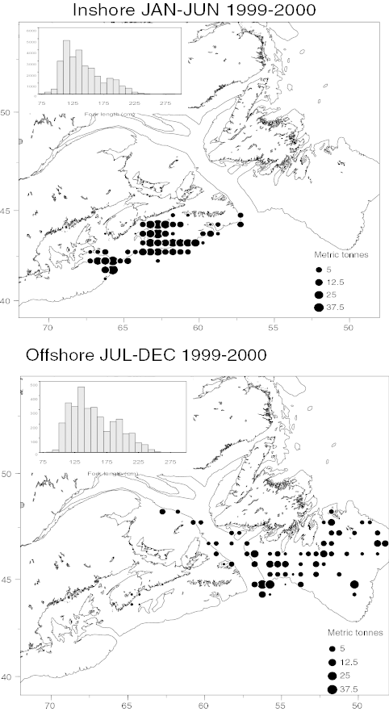

The size composition of the 1999 and 2000 catches was relatively similar between the inshore and offshore fleets. Spring and fall catches were dominated by small sharks (less than 175cm); the fishing vessels attempted to avoid catching large females in the spring. In recent years, the age of full recruitment to the fishery has dropped to an age of only 3 years in all areas.

The age composition of past and present landings was reconstructed between 1961-2000. Prior to 1991, the age of full recruitment off southern Newfoundland in the fall generally varied between 10-15 years, consistent with the use of this area as a mating ground by a lightly fished population.

Resource Status

The previous assessment of this resource was based on preliminary results from an intensive research program carried out in collaboration with the shark fishing industry. Standardized catch rates, tag-recapture analyses and indices of recent fishing mortality were used to suggest a F_{0.1} yield of 850t. However, there was insufficient information available at the time to determine a sustainable catch level and current fishing mortality rates.

An intensive research program on porbeagle shark was initiated in 1998 with the support and funding of the shark fishing industry. On-board collection of detailed measurements and tissues were made by scientific staff, while members of the fishing industry measured more than 75% of all sharks landed between 1998 and 2000. This information provided a view of the resource that is seldom possible in other fisheries, and greatly assisted in the preparation of this stock assessment. In addition, collaboration with the Apex Predator Program of NMFS in the USA provided access to both expertise and unpublished data. As a result, our understanding of porbeagle biology and population dynamics is among the best available for any pelagic shark species in the world.

The stock structure and migration pattern of porbeagle was studied through analyses of unpublished Norwegian, Canadian and US tagging studies carried out since the 1960s. All three studies demonstrated extensive annual migrations of porbeagle between the Gulf of Maine and the Gulf of St. Lawrence/southern Newfoundland, with no evidence of more than one stock. There was also no evidence of stock mixing between the western and eastern Atlantic.

Month to month shifts in length composition and sex ratios suggest a seasonal and sex-specific migration of mature sharks along the outer edge of the Scotian Shelf towards the southern Newfoundland mating grounds during the spring. The smaller, immature sharks resident on the Scotian Shelf appear to migrate relatively little.

Porbeagle exhibit well defined temperature preferences throughout the year. The mean temperature at mid-gear depth was 7.4 ⁰C, with 50% being caught between 5-10 ⁰C. Water depth ranged between 150-2300m in the spring, but most fall catches were made at depths <150m. The diet of porbeagles is mainly fish.

Percentage of females >175 cm FL in catch
The age and growth rate of porbeagle was determined after confirming the accuracy of vertebral growth bands as age indicators. In both sexes, growth rate decreases slightly at the onset of sexual maturity, with females growing to a larger size. The longevity of porbeagle sharks appears to be between 30-40 years.

Growth curve for porbeagle FL (cm) by sex
Porbeagle reproduction was studied to determine the potential productivity of the population. Males mature at about 174 cm FL (age 8) while females mature at 217 cm (age 13). Such a late age at maturation greatly reduces the productivity of the population. Mean litter size is 3.9 pups after a gestation period of 8-9 months; mature females appear to reproduce every year. Mating occurs in the early fall off of southern NF and at the entrance to the Gulf of St. Lawrence, but the birth location is unknown.

Annual trends in length composition were examined for evidence of high exploitation rate. Fall catches off of the southern Newfoundland mating ground have generally been dominated by large, sexually mature porbeagle, but the median fork length has declined since the early 1980s, suggesting a reduced abundance of large sharks. Median fork lengths in 1999 and 2000 were the smallest on record.

Median fork length (cm) in NF-Gulf in Sep-Oct
Trends in commercial catch rate were used as indicators of abundance, both in terms of overall biomass (kg/hook) and in terms of the numbers of sexually mature (>200 cm FL) and immature (<200 cm FL) sharks per hook. Catch rates (kg/hook) by the offshore fleet in all areas have declined to less than half of the levels present in the early 1990s. The history for the inshore fleet is much shorter, but shows a slight increase since 1998. Differences in area fished by the two fleets may explain the recent divergence in trends. The catch rate of mature sharks (number/hook) has declined markedly for both fleets since 1996 in all areas. The catch rate for immature sharks has also declined since the early 1990s, although it has remained roughly stable since 1996. The immature shark catch rate by the inshore fleet increased in 2000, while that of the offshore fleet declined further.

A catch rate analysis which adjusts for differences among fishing vessels, subareas and months, showed an increase in the catch rate of mature sharks between 1989 and 1992, followed by a marked decline to a very low level in 2000 (to about 10% of its peak level). This trend is consistent with the gradual entry of the Canadian fleet into the fishery in the early 1990s, followed by reduced abundance of the mature fish due to heavy fishing. The standardized catch rate for immature sharks showed a similar, but less marked decline since 1991 (to 30% of its peak level), although catch rates have been relatively stable since 1996.

Mature sharks per hook
Immature sharks per hook

Natural mortality rates for each sex were estimated from area-specific catch curves of the virgin 1961 population. The natural mortality rate (M) of immature porbeagles is about 0.10, increasing to 0.15 for mature males and 0.20 for mature females.

Three methods were used to estimate recent fishing mortality rate: Paloheimo Zs, Petersen analysis and a population model.

Paloheimo Zs are estimates of total mortality rate based on the effort-standardized decline in catch at age along a year-class. Paloheimo Zs on the Scotian Shelf and NF-Gulf were both estimated to be about 0.32 between the years 1998-2000. After adjusting for M, fishing mortality on ages 3-13 was estimated to lie between 0.18-0.22.

Fishing mortality (F) in the 1990s was estimated through Petersen analysis of tag recaptures. The analysis was restricted to sharks <125 cm FL, corresponding to ages 0 and 1. Both the US and Canadian tagging studies provided similar estimates of fishing mortality since 1994. After adjusting for the limited availability of the young sharks to the fishing gear, F was estimated to lie between 0.05-0.20, with a mean of about 0.11 since 1994.

An age- and sex-structured population model was fit to catch at length and catch rate data between 1961-2000 to estimate current population size relative to that of earlier years. Both total biomass and spawning stock numbers declined sharply after the onset of the 1961 fishery, recovering slightly through the 1970s and 1980s, and then declining once more to a record low level. Current biomass was estimated as being 11-17% of virgin biomass and fully recruited F in 2000 was estimated as 0.26.

Biomass (t) from population model

Fishing mortality from population model

Biological reference points were calculated from both a life table analysis and the population model. Life table analysis uses age-structured estimates of survival rate, sexual maturation and fecundity to project population growth, and is well suited to animals like sharks with a well defined reproductive cycle and high rates of survival. The intrinsic rate of population growth in an unfished porbeagle population is 5-7%. Fishing at F_{0.1}=0.18 is unsustainable, and will result in stock collapse. Fishing at F=0.08 results in zero population growth, while F=0.04 to 0.06 approximately corresponds to a maximum sustainable yield (MSY) of about 1000t.
This assessment contains several independent measures of recent fishing mortality. The range of fishing mortalities estimated from Paloheimo Zs, Peterson exploitation rates and the population model are shown by the range bars in the graph below, with the most likely value shown by the point. All methods indicated that recent fishing mortalities were around 0.2, well above sustainable levels.

Estimates of recent fishing mortality compared to reference levels

Sources of Uncertainty

There are several sources of uncertainty in this assessment. Mature sharks are seldom seen in the winter and spring, and their overwintering and birthing grounds remain unknown. This uncertainty could influence yield projections through effects on availability.

The age determination of old sharks (>15 yr) remains unvalidated, and has implications for the mortality rate calculations of mature females.

Another source of uncertainty includes some of the assumptions of the Peterson tag analysis, specifically those dealing with tag-induced mortality and tag loss and reporting rates.

Finally, some of the underlying assumptions of the population model are uncertain, particularly that of selectivity, which introduces uncertainty into the estimates of recent population status. The model represents a preliminary exploration of the population’s dynamics and requires further enhancement in some areas. While it conveys an overall view of the stock’s dynamics, estimates of recent population status have a broad range of uncertainty.

Although all of the measures of recent fishing mortality shown here are considered valid, that derived from Paloheimo Zs is considered most reliable, followed by that of the Petersen analysis and then the population model.

Outlook

Porbeagle sharks produce few offspring and mature at a late age compared to the age of first capture. This combination of life history characteristics makes porbeagle highly susceptible to over-exploitation. Average catches of about 4500t per year in the early 1960s resulted in a fishery which collapsed after only six years, and which did not recover for another 25 years. However, the fishery appeared sustainable during the 1970s and 1980s when landings averaged 350t annually, and the population slowly recovered. Catches of 1000-2000t throughout much of the 1990s appear to have once again reduced population abundance, resulting in lower catch rates and low numbers of mature females.

The two-year TAC of 1700t introduced in 1999, based on preliminary scientific information and with excellent cooperation from industry, resulted in preliminary estimates of F_{0.1} yield, mortality and stock abundance. Nevertheless, it was acknowledged at the time that the F_{0.1} yield was probably not sustainable. The current assessment confirms the unsustainability of fishing at F_{0.1} for porbeagle, and indicates that a fishing mortality above 0.08 will cause the population to decline. A fishing mortality of 0.04-0.05 corresponds to MSY, and is required if the population is to be allowed to recover. Several independent estimates of recent fishing mortality all suggest that recent catches averaging 1000t per year have resulted in an F of about 0.20. An annual catch of 200-250t would correspond to fishing at about MSY and would allow population growth. Annual catches of about 400t would not allow any population growth, nor room for error in the estimates. Current population size appears to be 10-20% of virgin levels.

The current porbeagle population is seriously depleted and will require a greatly reduced fishing mortality if recovery is to occur. Due to the low productivity of the species, recovery will not be rapid. However, annual catch levels of about 1000t will be sustainable over the long term once the population has recovered.

For More Information

Contact:

Steven Campana
Marine Fish Division
Bedford Institute of Oceanography
P.O. Box 1006, Dartmouth
Nova Scotia B2Y 4A2

TEL: (902) 426-3233
FAX: (902) 426-9710
E-Mail: campanas@mar.dfo-mpo.gc.ca
Shark Web site:
www.mar.dfo-mpo.gc.ca/science/shark

References

Campana, S., L. Marks, W. Joyce, and S. Harley. 2001. Analytical assessment of the porbeagle shark (Lamna nasus) population in the northwest Atlantic, with estimates of long-term sustainable yield. DFO Canadian Stock Assessment Secretariat Res Doc. 2001/067.

This report is available from the:

Maritime Provinces
Regional Advisory Process
Department of Fisheries and Oceans
P.O. Box 1006, Stn. B205
Dartmouth, Nova Scotia
Canada B2Y 4A2
Phone number: 902-426-7070
e-mail address: myrav@mar.dfo-mpo.gc.ca

Internet address: www.dfo-mpo.gc.ca/csas
ISSN: 1480-4913

La version française est disponible à l’adresse ci-dessus.

Correct citation for this publication:

DFO, 2001. Porbeagle shark in NAFO subareas 3-6. DFO Sci. Stock Status Rept. B3-09 (2001).

Some landing statistics were coded incorrectly in the past, but have been corrected in this assessment. Therefore, some of the landings values reported here may differ slightly from those in previous SSRs.

